SECTION A: Multiple-choice questions

Question 3
The amount of electrons required to obtain 0.12 mole of aluminium from a molten electrolytic cell will be:
A. | 0.040 mol
B. | 0.12 mol
C. | 0.24 mol
D. | 0.36 mol

Use the following information for Questions 7 and 8
A solution containing a mixture of 1.0 M KNO₃, 1.0 M Zn(NO₃)₂ and 1.0 M Cu(NO₃)₂ is electrolysed using platinum electrodes. The potential is increased in steps of 1.0 volt for 30 minutes until eventually only gaseous products are observed from both electrodes.

Question 7
The electrolytic process was stopped and the coating on the cathode examined. The materials coated onto the electrode from the platinum core outwards will be:
A. | copper and then zinc
B. | copper, zinc and then potassium
C. | copper only
D. | potassium only

Question 8
A gaseous product was:
A. | Nitrogen gas, N₂, produced at the positive electrode
B. | NO₂ gas produced at the negative electrode
C. | Hydrogen gas, H₂, produced at the positive electrode
D. | Oxygen gas, O₂, produced at the positive electrode

Section B: Written Report

Question 2: Introduction/Background (10 marks)
In this practical investigation, hydrochloric acid is added to a solution of sodium thiosulfate, Na₂S₂O₃, sulphurous acid solution (H₂S₂O₃) rapidly forms. The sulphurous acid then decomposes to form sulphur dioxide gas, water and a yellow precipitate of solid sulphur.
The overall equation for this process is summarised as:
Na₂S₂O_{3 (aq)} + 2HCl_{(aq)} → S_{(s)} + SO_{2(g)} + 2NaCl _{(aq)} + H₂O(l)

- What type of reaction is it? (acid-base, redox and/or precipitation). Explain your answer.

(2 marks)
- Based on your understanding of Collision theory, what are the requirements for a successful reaction to occur?

(2 marks)

- The reaction between sodium thiosulfate and hydrochloric acid is exothermic. Draw an energy profile diagram for this reaction. Make sure you label:

- Axes
- The reactants and products
- The amount of energy required to break the bonds in the reactants and the amount of energy released in the formation of the products
- The change in enthalpy (ΔH)

(4 marks)
- Define reaction rate and state how it was measured in this experiment.

(2 marks)

Question 4: Understanding and application of chemical principles (11 marks)

- Write an ionic equation for the reaction between sodium thiosulfate and hydrochloric acid (refer to Q 1).
(2 marks)
Another way of following the reaction between sodium thiosulfate and hydrochloric acid is to measure the change in mass of the reaction flask and contents over time. The graph below shows the results from this type of experiment.

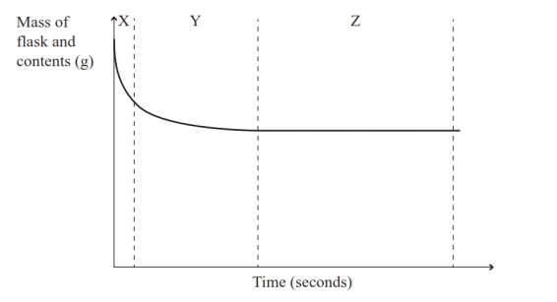

- Explain why the reaction rate is fastest in section X, why the reaction rate slows down in Section Y and is constant in Section Z.
Section X
Section Y
Section Z
(3 marks)
- “The rate of reaction between hydrochloric acid and sodium thiosulfate, Na₂S₂O₃ would only be affected by the temperature of sodium thiosulfate.”

- Explain why you agree or disagree with the statement above. Refer to your results in your discussion.

(2 marks)

Another experiment was carried out at 20ºC and then repeated at 40ºC. The sodium thiosulfate solution was added to the hydrochloric acid solution in a conical flask. The concentration and volume of both solutions were the same in both experiments. The flask was connected to an inverted measuring cylinder in a basin of water as shown in the diagram below.

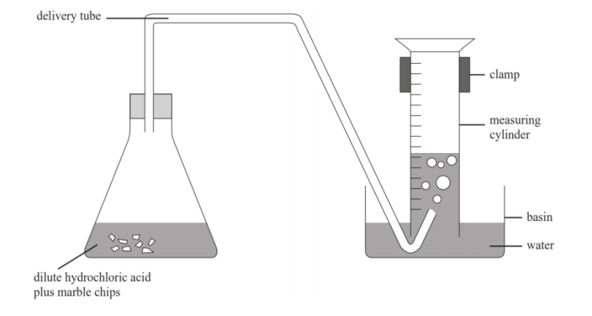
Dilute hydrochloric acid and sodium thiosulfate
- The volume of gas produced at the two different temperatures was measured for a few minutes and the results were used to sketch the graph shown below.
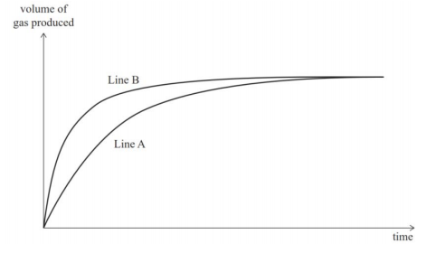
- Which line (A or B) on the graph represents the reaction at 40ºC? _______________________________

- Explain why the line you have identified is the reaction at 40ºC.

- Explain why the temperature has no effect on the final volume of sulfur dioxide produced.
(1 + 2 + 1 = 4 marks)

SECTION A: Multiple-choice questions

Use the following information for Questions 1 and 2
The reaction between sulfur dioxide and oxygen is described below:
2SO₂ (g) + O₂ (g) ⇌ 2SO₃ (g)
Question 1
The expression for the equilibrium constant for this reaction is:
- $K=\frac{{\left[{SO}_{2}\right]}^{2}+\left[O_{2}\right]}{{\left[{SO}_{3}\right]}^{2}}$
- $K=\frac{{\left[{SO}_{3}\right]}^{2}}{{\left[{SO}_{2}\right]}^{2}+ \left[O_{2}\right]}$
- $K=\frac{{\left[{SO}_{2}\right]}^{2} × \left[O_{2}\right]}{{\left[{SO}_{3}\right]}^{2}}$
- $K=\frac{{\left[{SO}_{3}\right]}^{2}}{{\left[{SO}_{2}\right]}^{2}× \left[O_{2}\right]}$

Question 2
The equilibrium constant for this reaction at 600ºC is 4.36 M⁻¹. Which of the following mixtures is at equilibrium?
 | [SO₂] | [O₂] | [SO₃]
A. | 1.50 M | 1.25 M | 0.90 M
B. | 1.50 M | 1.25 M | 3.50 M
C. | 1.50 M | 1.25 M | 3.91 M
D. | 1.50 M | 1.25 M | 0.80 M

Question 4
The following graph shows the concentrations of reactants and products over time. A change is introduced to the system at an initial equilibrium and the results are shown below:
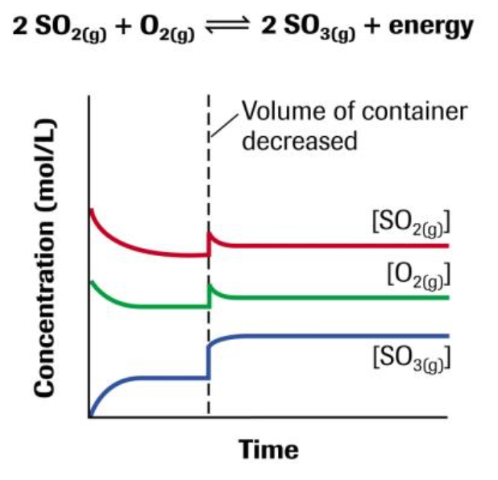
Change is introduced
The most likely change that was introduced is an
- increase in temperature
- increase in volume
- increase in pressure
- increase in O₂ (g) concentration.

Question 5
Aqueous solutions containing dichromate ions (Cr₂O₇²⁻) are orange, while those containing chromate ions (CrO₄²⁻) are yellow. These two ions can be converted to each other by the following reaction:
2 CrO₄²⁻ (aq) + 2 H⁺ (aq) ⇌ Cr₂O₇²⁻ (aq) + H₂O (l)
yellow orange
Which of the following statements is true for a mixture initially at equilibrium

- Addition of hydrochloric acid will make the mixture more yellow
- Addition of water will make the mixture more orange
- Addition of sodium hydroxide will make the mixture more yellow
- The colour of the mixture cannot be changed

Question 6
The reaction below is allowed to reach equilibrium at 450ºC.
CH₄ (g) + 2 O₂ (g) ⇌ CO₂ (g) + 2 H₂O (g) ∆H= -889 kJ mol⁻¹

After the temperature is increased, the amount of oxygen changes by 0.3 mole. One other change that will occur is:
- methane will increase by 0.15 mol
- carbon dioxide will increase by 0.15 mol
- water will increase by 0.3 mol
- carbon dioxide will decrease by 0.3 mol

Question 7
The ethanoic acid present in vinegar behaves as a weak acid.
CH₃COOH (aq) + H₂O (l) ⇌ CH₃COO⁻ (aq) + H₃O⁺ (aq)

A small amount of a strong acid is added to a solution of ethanoic acid. Then, after a period of time,
- The percentage ionization of CH₃COOH will have increased
- the pH will have decreased
- more CH₃COO⁻ (aq) will have been produced
- the value of the equilibrium constant K will have increased

Question 8
Which of the following solutions will have the highest pH value?

- 0.001 M HCl
- 0.1 M lactic acid
- 0.01 M propanoic acid
- 1 M hydrocyanic acid

Question 9
Congo red (CrH) is an indicator often used in acid-base reactions. It is a weak acid, whose acid form is blue while its conjugate base (Cr⁻) is red.
CrH (aq) ⇌ Cr⁻ (aq) + H⁺ (aq)

At the end point of a titration, the indicator changes colour and there are equal concentrations of the two coloured species. If the equilibrium constant for this reaction is 7.94 x10⁻⁵ M, then the indicator will change colour at approximately:

- pH 8.0
- pH 5.0
- pH 4.0
- cannot be determined from the information given

Question 10
Water undergoes self-ionisation via the following chemical equation.
H₂O (l) + H₂O (l) ⇌ H₃O⁺ (aq) + OH⁻ (aq)
When a sample of pure water is heated from 25 °C to 40 °C the pH of the sample decreased to 6.77. Which of the following statements are true:

- the self-ionisation of water is an exothermic reaction
- At 40 °C, [H₃O⁺] is greater than the [OH⁻]
- At 40 °C, [OH⁻] is greater than the [H₃O⁺]
- The equilibrium constant, K_{w}, for the self-ionisation of water at 40 °C is 2.88 $×{10}^{\text{-14}}$ M²

SECTION B

Question 3 (10 marks)

Phosphorus pentachloride gas can be decomposed into phosphorous trichloride gas and chlorine gas according to the following equation:

PCl₅ (g) ⇌ PCl₃ (g) + Cl₂ (g) ΔH = -120 J mol⁻¹

- Using Le Chatelier’s principle, outline and explain one physical change you could do to a mixture of gases at equilibrium to:

  - Increase the amount of products

  - Increase the amount of reactants
(2 + 2 = 4 marks)

- Write the expression for the equilibrium constant for this reaction.
(1 mark)

- At a particular temperature, 0.500 mol of PCl₅ (g), 0.100 mol of PCl₃ (g) and 0.0500 mol of Cl₂ (g) were mixed in a 3.00 L vessel and allowed to reach equilibrium. Analysis showed that 0.310 mol of PCl₅ (g) was present in the gas mixture at equilibrium. Calculate the value of the equilibrium constant at this temperature.
(5 marks)

Question 4 (5 marks)

The conversion of brown nitrogen dioxide gas, NO₂, to colourless dinitrogen tetroxide gas, N₂O₄, is endothermic. This reaction can be represented by the following chemical equation:
N₂O₄ (g) ⇌ 2NO₂ (g)
A 200 mL gas syringe containing the two gases are at an initial equilibrium.
- If the gases are then decompressed by increasing the volume of the gas syringe, circle the correct responses below for the changes that would occur to the system.
 | Circle the correct response
- Initial change to the concentration of the gases | Would increase | Would decrease | Would remain the same
- Concentration of NO₂ at the new equilibrium | Would be higher compared to the initial equilibrium | Would be lower compared to the initial equilibrium | Would be the same as the initial equilibrium
- The amount of NO₂ | Would be higher compared to the initial equilibrium | Would be lower compared to the initial equilibrium | Would be the same as the initial equilibrium

(1 + 1 + 1 = 3 marks)

- Explain how you would change the temperature of the 200 mL gas syringe to increase the yield of dinitrogen tetroxide in the container.
(2 marks)

